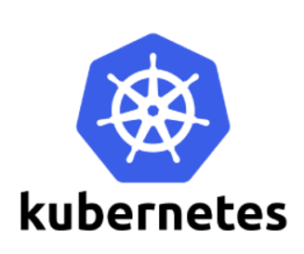

**Replication Controller**

Replication Controller is one of the key features of Kubernetes, which is responsible for managing the pod lifecycle.

**To scale up and scale down the pod replicas**

It is responsible for making sure that the specified number of pod replicas are running at any point of time. It is used in time when one wants to make sure that the specified number of pod or at least one pod is running. It has the capability to bring up or down the specified no of pod.

* Replication controller job is to maintain the exact number of pods which we defined in tha manifest file (eg: replica=4)
* Replication
* Component of Replication Controller

Replica Count

POD Selector

Labels

* It works in Declarative model (eg: replica=4)
* If any pod is deleted,it takes own action to restore the state
* Relocation- Pods will never relocate to another Node
* Can Create using files Yaml or json format

rc commands

to scaleup or scale down

kubectl get rc

kubectl scale <resourcetype> <replicationcontrollername> --replicas=<no of replica>

kubectl scale replicationcontroller cginginx-rc --replicas=4

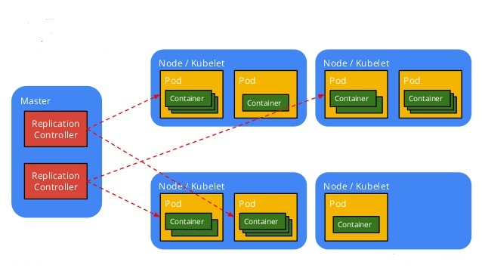

to create replication controller POD.

Syntax: kubectl run <name for the replication controller> --image=<image name>--generator=run/v1

Example: kubectl run mytest-rc --image=nginx --port=80 --generator=run/v1

• Pod - use run-pod/v1.

• Replication controller - use run/v1.

apiVersion: v1  
kind: ReplicationController  
metadata:  
    name: rep-pod  
spec:  
    replicas: 4  
    selector:  
       app: web  
       env: test  
    template:  
       metadata:  
          labels:  
             app: web  
             env: test  
       spec:  
          containers:  
          - name: rep-cont  
            image: nginx

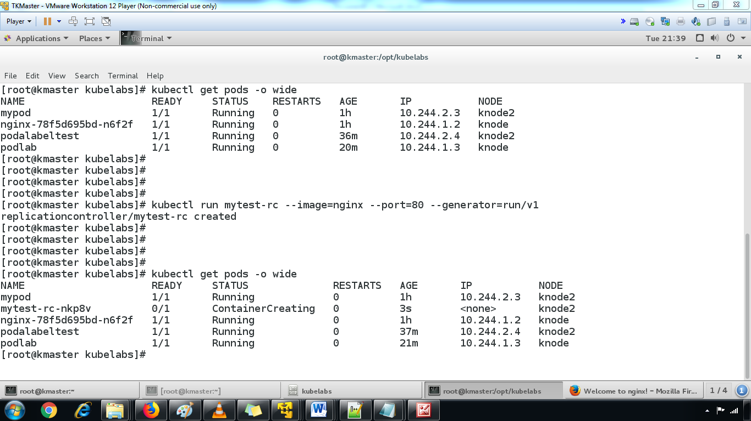

2.to verify the replication controller through describe command.

kubectl describe replicationcontrollermytest-rc

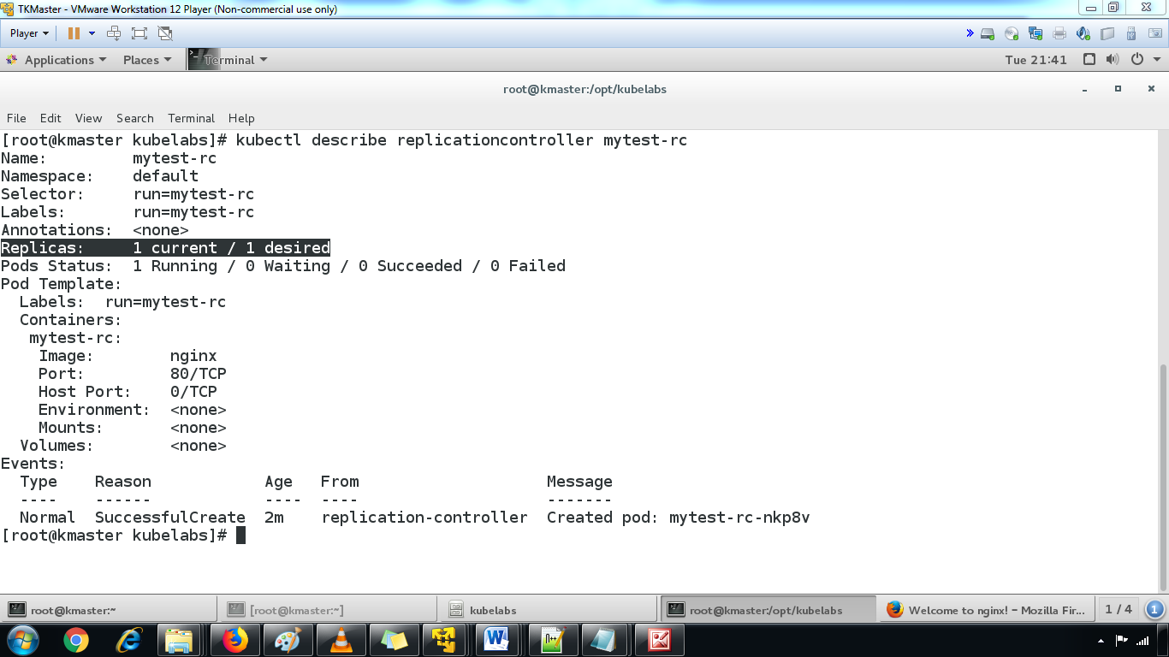

3. scaling up the pod replicas

command to increase the replica set.

By default, it will create only one POD if we do not specify the replica set numbers. You can verify it by listing the pods

Syntax: kubectl scale <resource type><replication controller name> --replicas=<number of required replicas>

Example: kubectl scale replicationcontrollermytest-rc --replicas=4

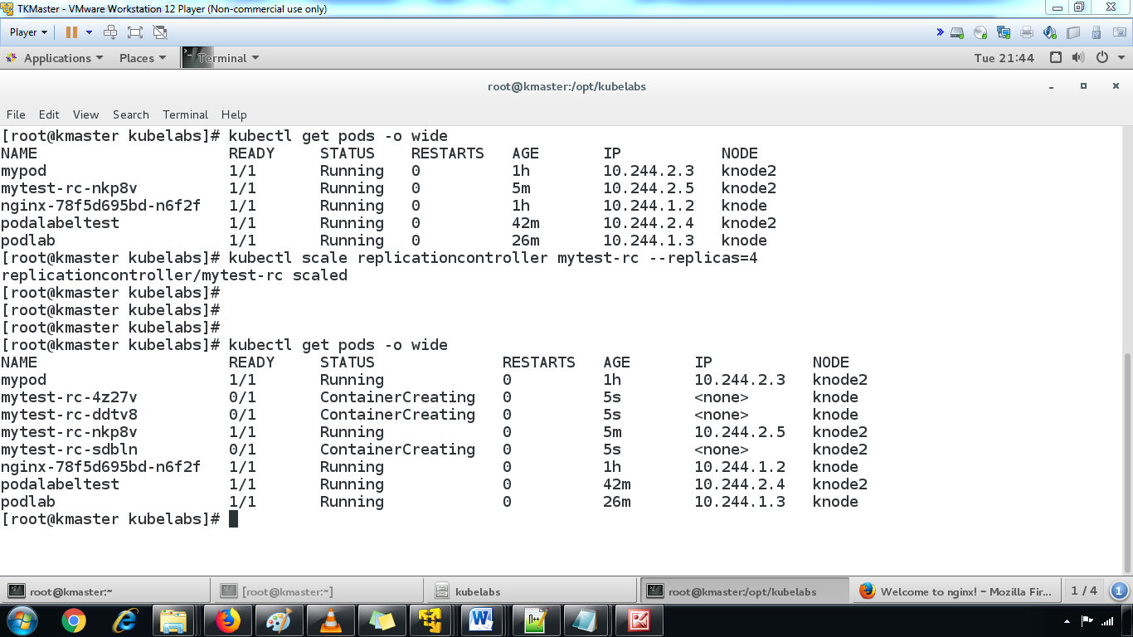

4.to find the pods events through describe command.

kubectl describe pods mytest-rc-4z27v

